TITLE OF THE ARTICLE FOR
OLADE's ENERLAC MAGAZINE

TÍTULO DEL ARTÍCULO PARA LA
REVISTA ENERLAC DE OLADE

Received: DD / MM / YYYY and Accepted: DD / MM / YYYY

Abstract
This space should include a synthesis of the scope and content of the research. The wording should follow the basic structure of the article, explaining the core problem of the research, as well as the general objectives and the theoretical basis that will validate the research process. The most important conclusions and recommendations reached after the investigation should be mentioned, as well as to whom the investigation is directed or to whom it might be useful. The maximum length of the paper will be 200 words.

KEYWORDS: It should include between 5 to 7 keywords in order of thematic relevance and separated with commas that indicate the basic aspects of the work. To select the keywords, the use of the Unesco Thesaurus and the Abbreviated List of Subject Headings of the National Library of Spain is recommended. For assistance in using the Thesaurus and the List of Subjects, contact centro.documentacion@olade.org.

Resumen
En este espacio se debe incluir una síntesis del alcance y del contenido de la investigación. La redacción debe seguir la estructura básica del artículo, explicando el problema central de la investigación, así como los objetivos generales y la fundamentación teórica que validará el proceso de investigación. Se debe mencionar las conclusiones y recomendaciones más importantes a las que se ha llegado luego de la investigación, así como a quien va dirigida la investigación o a quien podría ser de utilidad. La extensión máxima del mismo será de 200 palabras.

PALABRAS CLAVE: Se deberá incluir entre 5 a 7 palabras claves en orden de relevancia temática y separadas con comas que indican los aspectos básicos sobre los que trata el trabajo. Para la selección de las palabras clave se recomienda el uso del Tesauro de la Unesco y la Lista Abreviada de Encabezamientos de Materia de la Biblioteca Nacional de España. Para asistencia en el uso del Tesauro y la Lista de Materias comunicarse con centro.documentacion@olade.org.

1. INTRODUCTION

This section should include an introduction to the research work, mentioning its background, objectives and scope.

In this case, this document is intended to serve as a guide for potential researchers interested in publishing their technical articles in ENERLAC, specifying the characteristics of structure, form and style that the documents must comply with, as well as a summary of the relevant information of the process of revision and acceptance of the document by ENERLAC's editorial committee.

2. FIRST ORDER HEADINGS

For example, "1. Introduction, "it must be Times New Roman 13-bold, initially in uppercase, to the left, with a blank line before, and a blank line after.

2.1 Second order headings (Subtitle)

As in this header, Times New Roman should be 11 bold, initially capital letters, with a blank line before and one after.

2.1.1 Titles of third order: Use Times New Roman of 11 - bold, initially in capital letters, aligned to the left and a blank line, followed by a colon and your text on the same line.

3. Footnotes

Use the footnotes in moderation, place them at the bottom of the column of the referenced page. Use the Times New Roman 9, single space.

SPECIAL ASPECTS

• Article length:

The maximum length of the article must be 20 pages that includes: body of the text, citations, footnotes, pictures, illustrations, maps, photographs, graphics, annexes, others and bibliographical references on the last page.

• Format and style rules for the presentation of the article

- Upper, lower, left and right margins 2.5 cm
- Spacing 1.15 Justified
- Approximately 450 words per page
- Times New Roman typeface
- Size: 13pt
- General body text, Times New Roman Regular, size 13 pt
- Title, subtitles, Times New Roman Bold, size 13 pt
- Words in another language Times New Roman Italic, size 13 pt

• Figures and Tables

Figures and tables should be clear and for clarity of the image the entire width of the sheet can be used. The title of the figure or table must be placed at the top, indicating the corresponding numbering, as shown in the following example:

Figure 9. Percentage of technical potential of renewables in the region compared to the world

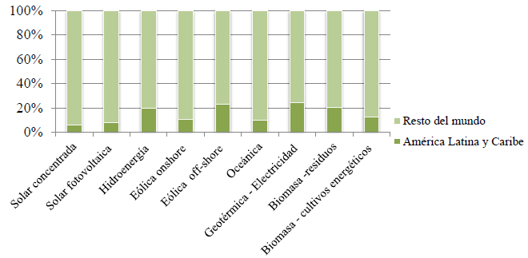

Source: Own elaboration with data from the study of potential (Hoogwijk & Graus, 2008).

Example of title and numbering for tables:

Table 2. Barriers Analysis and change proposal

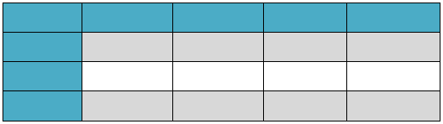
Source: Own elaboration, 2018

Tables, tables and graphs should be sent in their original format, preferably Word or Excel, indicating exactly where they should be placed in the text.

The maps, photographs, illustrations, images should be sent in JPEG format, in high quality, indicating, with accuracy, the place of the text in which they should be located.

Use the comma (,) for the separation of thousands and the period (.) for the separation of decimals, in order to standardize the use of unit separators.

REFERENCES

References should be made according to the rules of the American Psychological Association (APA) and in alphabetical order. In the APA format, the reference should be cited in the text and additionally added to the reference list. Below is an example of a paragraph with its respective appointment and how it is added to the list of references with APA standards:

“The CIER is an international regional organization, recognized by governments, of unlimited duration and non-profit making, which brings together companies and organizations of the energy sector of the Member Countries, as well as Associate Members and Related Entities, with the objective of promoting and favoring the integration of the energy sector in the region through mutual cooperation among its members. It is currently developing projects on international interconnections and energy integration; one of the projects is the Latin American Energy Atlas and SIGER Database. (CIER, 2016).”

In the list of references, at the end of the document, you should see:

CIER. (December 14, 2016). Regional Energy Integration Commission. Obtained from International Organization of the Energetic Sector of Latin America and the Caribbean: www.cier.org.uy

In Microsoft Word, in references, you can use this form of reference automatically selecting the APA style option.

ABBREVIATIONS AND ACRONYMS

Abbreviations and acronyms must be defined the first time they are used, even though they have been defined in the summary of the article.

EQUATIONS

The equations must be numbered consecutively in parentheses, the numbering must be aligned to the right side. Insert the equation with the equation editor of Microsoft Word.

𝐸=𝑚×𝑐2 (1)

CONCLUSIONS

The conclusions should refer to the most important contributions found throughout the research. Remember that the conclusions are not a summary of the article. The conclusions demonstrate the importance of the research carried out and the fulfillment of the researcher's objectives with the study. They are also a space where we expect to find the author's recommendations for extensions and / or direct applications of the research.

APPENDICES

Appendices, if necessary, should be presented before the references.

REFERENCES
Below is an example of references following the APA standards:

CAF. (2013). Energy: A vision of the challenges and opportunities in Latin America and the Caribbean. Energy integration ALADI, ARPEL, CAF, ECLAC, CIER, OAS, OLADE, WEC-LAC.

CAF, CIER. (2012). New opportunities for electrical interconnection in Latin America. Bogotá: - Development Bank of Latin America

Campillo, S. (27 de abril de 2016). Electric crisis, Venezuela. Hypertextual.

Carrasco, J. (2013). New approach to the Regional Energy Integration of Latin America - PR CIER 15. Santa Cruz de la Sierra. Bolivia: CIER.

Castillo, I. (2013). Notes on regional electricity integration and proposals to move forward. Quito: OLADE.

CELEC EP. (2015). Project information sheet 2015. Pre-feasibility study of bi-national geothermal project Tufiño - Chiles - Cerro Negro. Quito, Ecuador: Electric Corporation of Ecuador.

CIER. (December 14, 2016). Regional Energy Integration Commission. Obtained from International Organization of the Energetic Sector of Latin America and the Caribbean: www.cier.org.uy

Clavijo, S. (2016). The energy crisis in Colombia (2015-2016). National Association of Financial Institutions (ANIF).

CNE. (2016). Generation installed capacity. Chile: National Energy Commission

CNEA. (2015). synthesis of the wholesale electricity market of the Argentine Republic. Deputy Manager of Strategic Planning Management of Planning, Coordination and Control. National Atomic Energy Commission.

ENEE. (2015). Statistical Bulletin, December 2015. Honduras: Strategic and corporate planning management.

Gigardi, R. (2016). Planning and energy integration in Central America: Analysis of the expansion of the electricity sector and slternatives for the supply of natural gas. Latin American Energy Organization (OLADE).

